QUOTATION FORM

DATE:02 /02/2025

VENDORS NAME: …………………………… RUBBER STAMP: …………………

SIGNATURE: ……..…………………………….. CONTACT: ……………………

You are kindly invited to submit your quotation for the items in the table below under the following terms and conditions and the required specification
- The Quotation is not an order.
- The payment will be done on measure and pay basis
- The quotations should indicate final unit prices
- Alteration of the prices is NOT accepted
- The decision of the tender Committee is final. Canvassing will lead to disqualification
- ONLY qualified vendor will be contacted.
- Quotation should be received at World Vision Galkacyo south Galmudug Office not later than 09/02/2025 at 90;00AM

Subject: Request for Quotation of Office Furniture

N/s | Description | Unit | Quantity | Unit Price | Total
1 | Office Chair (Evo Task Chair, Black - Dusk Mesh) | Each | 17
2 | Office Desk (anel Rectangular Desk + 3 Drawer | Each | 17
3 | Cupboard (Cupboard MWOC-002 “72 x 45 x 40) | Each | 5
4 | Closet (Metal) (2.5m x 1.8m) | Each | 1
# | Total

* All quotation forms should be returned to World Vision Galkac south office while sealed.

Please fill out the below information

The delivery time;

Are item in stock;

The validity of your quotations;
Payment Terms;

Supplier eligibility Criteria;

- Tax clearance from Ministry of finance (Galmudug state)
- Valid license from the Ministry of commerce (Galmudug state)

Technical criteria;

- Similar past experience (evidence of similar experience from three client)
- Bank statement of the last one year (to showcase the financial stability of the supplier)
- Evidence of owning furniture shop/ similar business, such as Business Profile

Submission procedure and the deadline;
All submissions must be sent in a sealed envelope to the specified office address before the deadline, which was noted as February 9th 2025.

Specification
No. | Item | Description | Specification
1. | Office Desk | Panel Rectangular Desk + 3 Drawer Mobile Pedestal Bundle 1200X800 Grey Oak/Grey Oak | 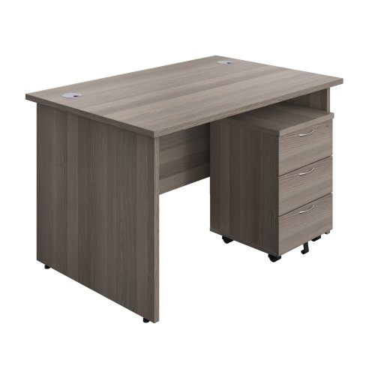
2. | office Chair | Evo Task Chair, Black - Dusk Mesh | 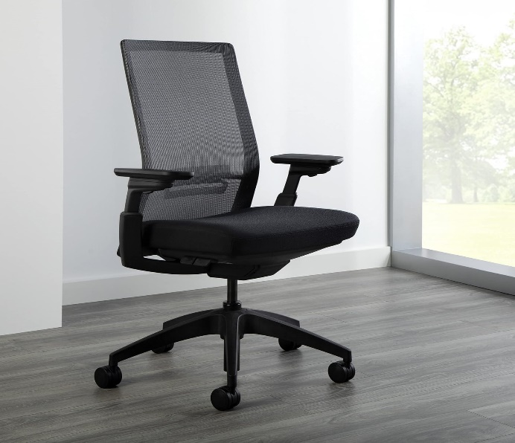
3. | Cupboard | Cupboard MWOC-002  “ 72 x 45 x 40 | 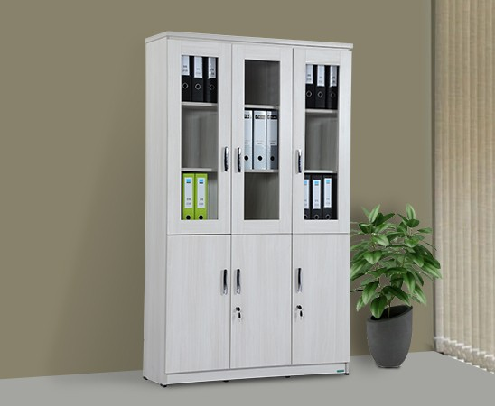
4. | Closet ( Metal) | 2.5m x 1.8m | 