INVITATION TO BID (ITB)
Vendor / Company Name: ____________________________________________________

Date: ____________________________________________________

Cell phone: ____________________________________________________

Date: 4th December 2025 | No. of pages including this page: 3
Bid title: NFI Supplies | Ref no:
Contacts: | Tel: 570864/634676251

- Background:

Plan International strives to advance children’s rights and equality for girls all over the world. As an independent development and humanitarian organization, we work alongside children, young people, our supporters and partners to tackle the root causes of the challenges facing girls and all vulnerable children. We support children’s rights from birth until they reach adulthood and enable children to prepare for and respond to crises and adversity. We drive changes in practice and policy at local, national and global levels using our reach, experience and knowledge. For over 85 years, we have been building powerful partnerships for children, and we are active in over 87 countries.

Submission:
Completed bid documents (Mandatory Requirement along with the Quote) in sealed envelope clearly marked with the NFI Supplies.
All BID documentations must be submitted electronically to the following email address: Som.Procurement@plan-international.org Please ensure the subject of your email reads: " Bid Submission for NFI Supplies"
Closing deadline: time: 12.00 pm date: 10 December 2025

Important:
Offers transmitted in any other manner than those indicated above will not be considered.

Requirements:

Plan International Somalia/Somaliland invites qualified and reputable Suppliers with proven experience in procuring NFI Supplies to make an offer based upon the conditions stated in this invitation to the bid for the items in Annex 1.

Your offer should clearly indicate:
- Unit price and total price as per the attached RFQ
- Price should be net after deduction. Applicable taxes must be clearly specified and separated from the base costs and should be inclusive of the delivery and transportation cost.
- Validity of the offer.
- Delivery time should also be specified.
- Provide a supplier email and telephone contacts

Information to bidders:
- Currency of offer should preferably be in US Dollars, but in case local currency is offered, the comparison of offers will be based on the prevailing rate of exchange.
- Plan international reserves the right to accept the whole or part of your offer.
- Plan International reserves the right to accept or reject any application (bid), and is not bound to give reasons for its decisions. Giving false information will lead to automatic disqualification.
- Tender prices must remain valid for 90 days from the date of tender closing

EVALUATION CRITERIA

- Mandatory Requirements:

- Provide a certified copy of a certificate of business registration.

- Provide a certified copy of tax registration or tax clearance

- Provide references from previous customers especially INGOs.

- Updated bank statement

NB: The NFI Supplies will delivered at Awdal Region

ANNEX 1: Request for Quotation NFI Supplies
S/N | Item | Description | Quantity | Photo | Unit Price | Total Price
1 | Blankets | Double Size: Woollen Blanket, 220*240cm t.w: 12.8lbs | 2 | 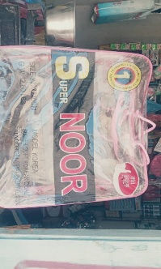
2 | Solar Lamp | Portable Solar Powered LED Lamp with 0.5W/ 4.4V mono crystalline solar panel with rechargeable battery | 1 | 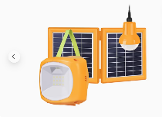
3 | Sleeping mats | 2.7mx1.8M synthetic sleeping mats | 1 | 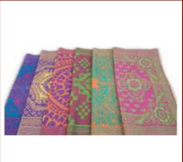
4 | Plastic sheet | 4m x 5m plastic tarpaulins | 1 | 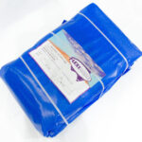
5 | Bed- sheet | Bed sheet -1.5m x 2.2m | 2 | 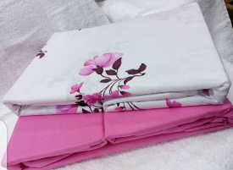

Please note that the total quantity required is 800 Packages, where each package will contain:
- Two Blankets
- One Solar Lamp
- One Sleeping mat
- One Plastic sheet
- Two Bed- sheet

